# Lab Week 2. Conditionals & Loops

## Learning Objectives

* Using For Loop
* Local variable – for loop counter
* Using Nested loops

## Resources

* Lecture Notes
* Processing website – reference
* https://processing.org/reference/for.html

**Exercise 1**

int x=10; //declare int variable called x put 10 in there

int y=20; //declare int variable called y put 20 in there

size(100,100); //set size of canvas screen

for(int i=0; i<5; i=i+1)

{

x=x+10;

print(" i:"+i+",x:"+x); //display variable value in console window

ellipse(x,y,5,5);

}

Enter the code precisely as above, and run.

Note the print command, prints the value of local variable **i** and global variable **x** to the console (bottom of sketch window)

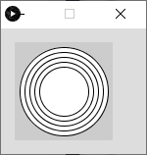Alter the code so we get a horizontal line of 10 circles on the screen. You may have to increase the size of your canvas.

Write a new program so that you get 5 concentric circles in the middle of the canvas

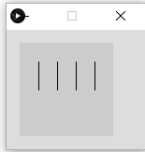

**Exercise 2**. Produce code to show 4 parallel vertical lines of length 50, 20 pixels apart.

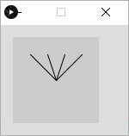

Code to produce, this pattern. Note this is similar to the previous problem, but the end points of all the lines are the same.

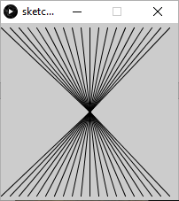

Produce a design for this pattern – comments at the top of a new sketch

Turn your design into code.

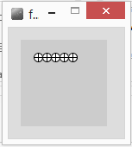**Exercise 3.** Design and code a program to show a row of 5 wheels

Design and code a program to draw 10 wheels in a vertical column

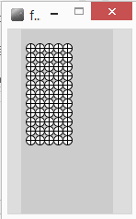Alter your program code so we get a block of wheels – 5 wide, by 10 deep

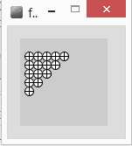

**Exercise 4**. Produce a program to draw each image

Hint – use a variable to control how many repetitions a loop performs

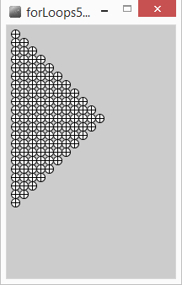

Ex4B. Produce some code to draw wheels across the screen using a while loop

[hint : **width** is a built-in variable that holds the width of the screen]

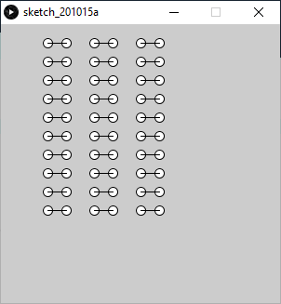**Exercise** **5**. Produce a program to draw this pattern

**Design stages**,

* Draw a dumbbell, 2 ellipses and a line from each centre
* Draw a column,
* Draw 3 columns

A Good solution should show evidence of the design as comments, use all concepts covered so far. Best solutions will allow easy rescaling and repositioning of the pattern. More marks are available if you complete and sign off for your next lab.

**Exercise 6** Try out the code below, what does it do and why?

float x= 25;

float y=25;

float radius = 20;

float angle; //in radians

for(int degrees=0; degrees<360; degrees = degrees+10)

{

angle = **radians**(degrees); //convert degrees to radians

**line**(x,y, x+radius\***sin**(angle),y+radius\***cos**(angle));

}

Put the code below into the for loop to change the colour of each ‘spoke’.

float r = **random**(50); //random number [0..50]

float g = **random**(50);

float b = **random**(50);

**stroke**(r*5,g*5,b*5); //random line colour

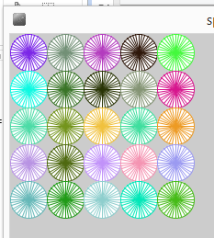

**Exercise 7**. Pop art Wheels, a 10 by 10 block of wheels, each of a different random colour

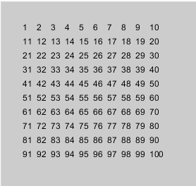**Extension exercise**.

text("*", 100,100); //draws a text string ‘*’ at position 100,100

int count=10;

text(“”+count, x,y); //draws value of count at x,y

draw the image, left.

Extension exercise (optical illusion), needs an if statement and a Boolean variable ( a flag )

